# INTRODUCTION

# Overview

Evaluation of financial position of any business enterprise can be done through financial analysis. Financial analysis tries to look at the capital cost, operating expenses and operating income. The analysis also establishes a relationship between as a common measure of value for getting a clear understanding about the unit from the financial point of view. One can get a clear idea about financial Strengths and weakness of a particular business enterprise, after tracing down the financial position of the organization.

**Purpose**

1. To study the growth and performance of Banks.
2. To measure and compare the efficiency of Banks.
3. To suggest the appropriate measures to improve the efficiency and financial health of Banks.
4. **Problem Definition & Design Thinking**

Empathy Map

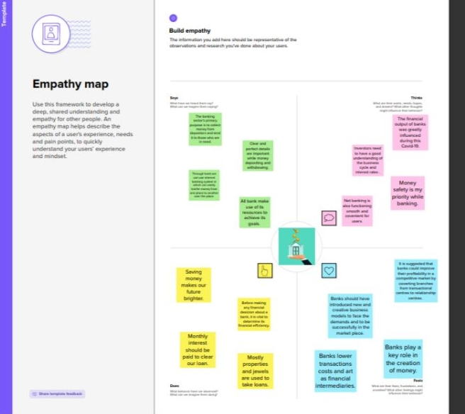

* + Ideation & Brainstorming Map
  + 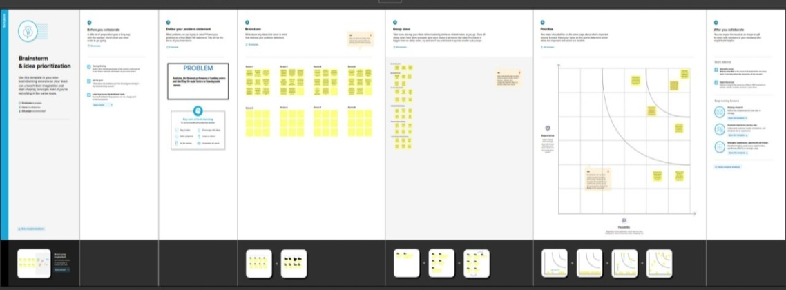

# RESULT

# Dashboard

# Screenshot (12).png

**Story**

**Story1**

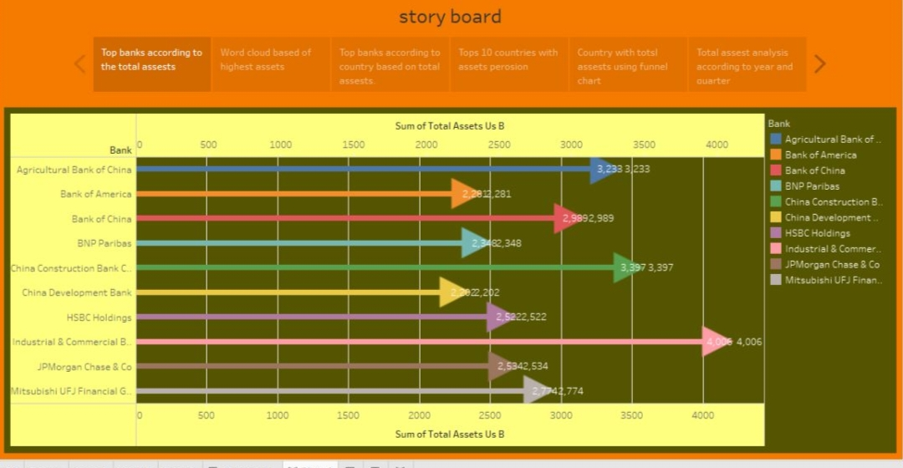

**Story 2**

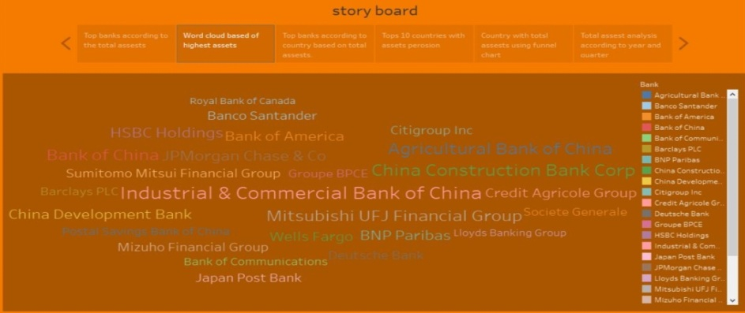

**Story 3**

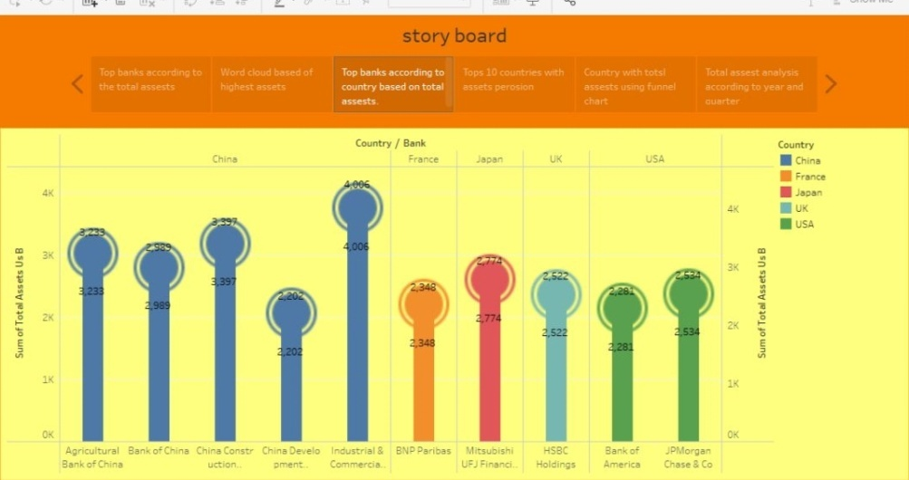

**Story 4**

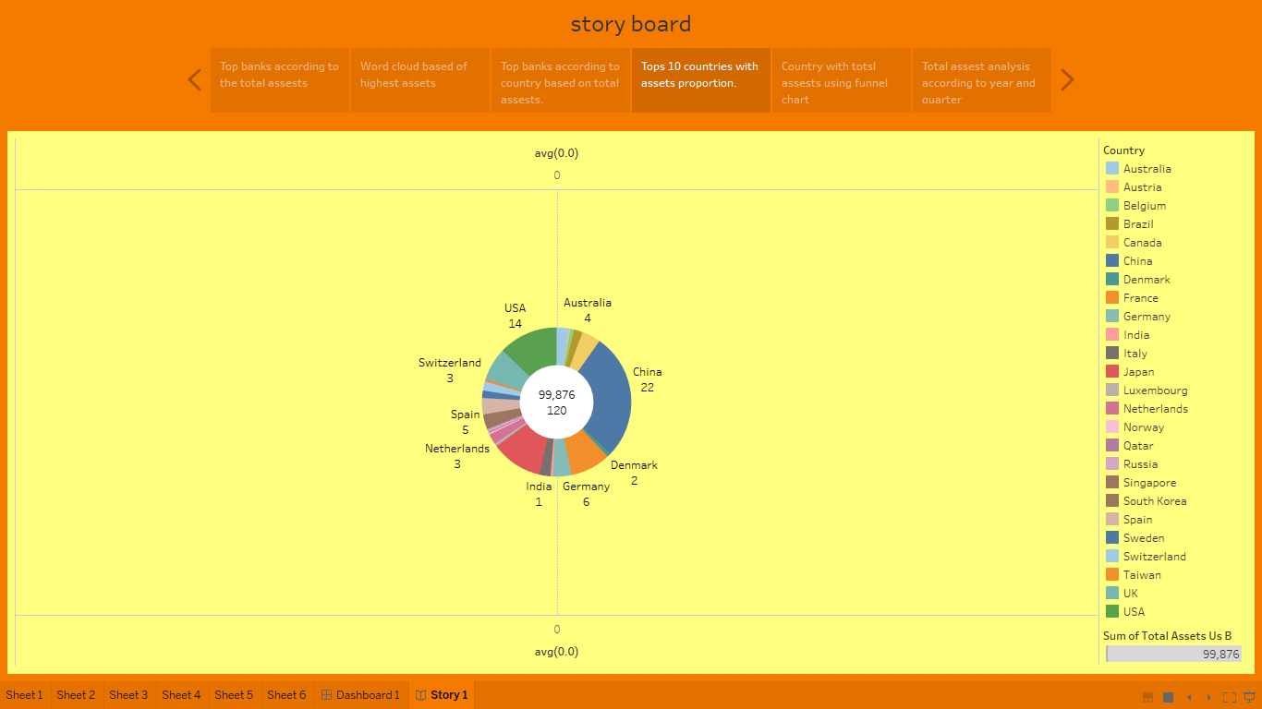

**Story 5**

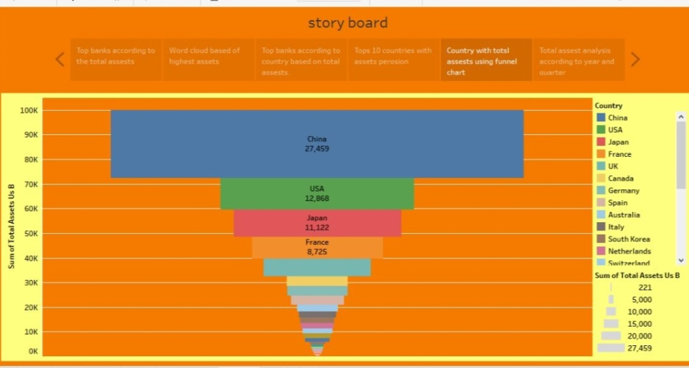

**Story 6**

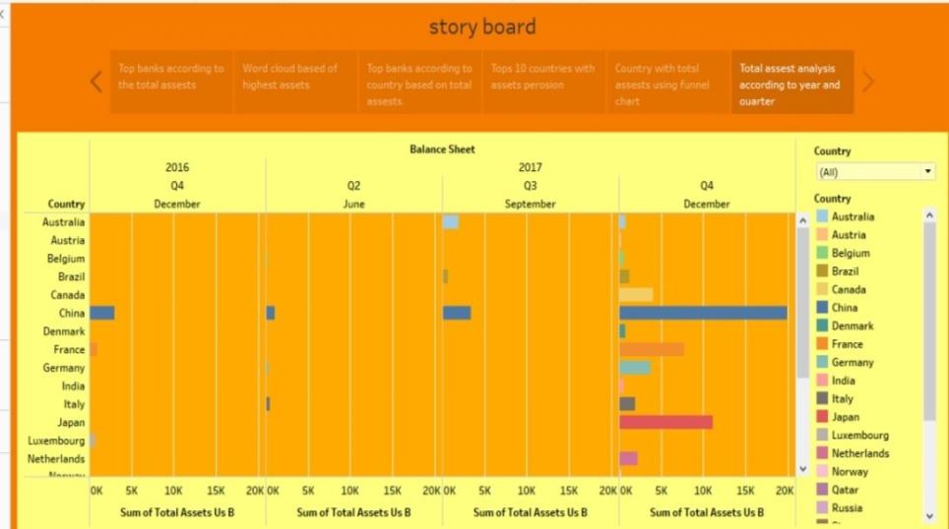

**4 ADVANTAGES & DISADVANTAGE**

Advantages:

Financial statements are financial data documents a company publishes on an annual, biannual, quarterly or monthly basis. These documents include the company’s net worth based on assets and liabilities, as well as the company’s expenses, earnings and operational budget. Financial planners, senior executives and accountants may use financial statements to make decisions regarding future planning, expansions and product launches, but there are disadvantages to using this method.

1. The Ability to Detect Patterns

Financial statements reveal how much a company earns per year in sales. The sales may fluctuate, but financial planners should be able to identify a pattern over years of sales figures. For example, the company may have a pattern of increased sales when a new product is released. The sales may drop after a year or so of being on the market. This is beneficial, as it shows potential and sales patterns so executives know to expect a drop in sales.

1. A Chance to Budget Outline

Another advantage of using financial statements for future planning and decision making is that they show the company’s budgets. The budgets reveal how much wiggle room the company has to spend on launching products, developing marketing campaigns or expanding the current office size. Knowing how much money is available for planning and decision making ensures that the company does not spend more than expected.

Disadvantage

1. Based on Market Patterns

One disadvantage of using financial statement for decision making is that the data and figures are based on the market at the given time. Depending on the market, it may change quickly, so executives should not assume that the numbers from a previous financial statement will remain the same or increase. Just because a company has sold 5 million copies of a product during one year does not guarantee it will sell the same amount or more. It may sell much less if a competitor releases a similar products.

1. At-One-Time Analysis

Another disadvantage is that a single financial statement only shows how a company is doing at one single time. The financial statement does not show whether the company is doing better or worse than the year before, for example, if executive decide to use financial statement for making decisions about the future, they should use several financial statements from previous months and years to ensure they get an overall picture of how much the company is doing. The financial statement becomes a continuous analysis, which is more useful than using a single statement.

# 5 APPLICATIONS

1. Fraud detection

While fraud reduction is a common goal for banks and financial institutions, analytics can be used to manage risk instead of simply detecting fraud.

Analytics can be used to identify and rate individual customers who are at risk of fraud and then apply different levels of monitoring and verification to those accounts. Analyzing the risk of the accounts allows banks and financial institutions to know whatto prioritize in their fraud detection efforts.

1. Risk modeling for investment banks

Risk modeling is the process of simulating how a portfolio of assets (stocks, bonds, future, option, etc,)or a single assets (such as an interest rate)moves in response of different scenarios. When risk modeling is done correctly and consistently across all assets, you can reduce your portfolio’s overall risk and improve its performance.

1. Credit risk analysis

Banks and financial institution use analytics to manages the risk associated with the loans they make. This is done by monitoring data they collect on individual customers.

Credit risk analysis is the analysis of historical data to understand a borrower’s creditworthiness or to assess the risk involved in the granting of a loan. The results of the analysis help banks and financial institution evaluate their risks and those of their customers.

1. Operational and liquidity risk

The term “operational risk” is used to describe the potential for loss due to action taken by the business. Operational risk encompasses risks that are specific to an individual financial institution.

In contrasts, liquidity risks is more macro in nature, including issues such as interest rate fluctuation, changes in foreign exchange in the value of other financial instruments, such as bonds.

The Operational risks are possible losses that result directly from risks associated with day-to-day operations of the institutions, i.e., fraud, theft, computer security breaches, or error in judgment or incompetence at an executive level.

For example, a bank has a limited number of teller machines available. If the bank doesn’t have enough tellers on duty at all times, if can increase its operational risk by having too few staff to serve customers properly.

# CONCLUSION

“As the literature is the mirror of a society’s culture and civilization, the banks are barometers of a nation’s economy. The prosperity and decline of an economy immediately known from the extent of banking business”

The study may be a helpful step ahead in increasing the morale of each Employee. By studying this, Bank will can come to know that what effective measure can be take to maintain the effective use of resources. Such results and conclusions are definitely helpful in order to achieve goals of the organization in this modern business world.

FUTURE SCOPE

According to Framework for the preparations and presentation of financial statements. Then role of financial reporting by companies is to provide information about their performance, financial position, and changes in financial position that is making economic decisions.

The purpose of financial statement analysis is to evaluate the past, current, and future performance and financial position of the company for the purpose of making investment, credit, and other economic decisions.

Financial statements are the end results of an accounting record-keeping process that records the economic activities of a company. They summarize this information for use by investors, creditors, analysts and other interested in a company’s performance and financial position

The key financial statements that are the focus of analysis are the income statements, balance sheet, statement of cash flow and owner’s equity. The income statement and statement of cash flows portray different aspects of a company’s performance over a period of time.

Financial Analysis acts as damage control for the companies so that the tides don’t upset the throttle of the company to evolve in the business arena hence to restore and majorly revive the situation to bracket the damage to confine it in a closed forum is amalgamated through financial analysis.

APPENDIX

Code

<!doctype html>

<html lang="en">

  <head>

    <title>Bank performance analysis &mdash; Website Template by Colorlib</title>

    <meta charset="utf-8">

    <meta name="viewport" content="width=device-width, initial-scale=1, shrink-to-fit=no">

    <link href="https://fonts.googleapis.com/css?family=Open+Sans:300,400,700" rel="stylesheet">

    <link rel="stylesheet" href="fonts/icomoon/style.css">

    <link rel="stylesheet" href="css/bootstrap.min.css">

    <link rel="stylesheet" href="css/jquery-ui.css">

    <link rel="stylesheet" href="css/owl.carousel.min.css">

    <link rel="stylesheet" href="css/owl.theme.default.min.css">

    <link rel="stylesheet" href="css/owl.theme.default.min.css">

    <link rel="stylesheet" href="css/jquery.fancybox.min.css">

    <link rel="stylesheet" href="css/bootstrap-datepicker.css">

    <link rel="stylesheet" href="fonts/flaticon/font/flaticon.css">

    <link rel="stylesheet" href="css/aos.css">

    <link rel="stylesheet" href="css/style.css">

  </head>

  <body data-spy="scroll" data-target=".site-navbar-target" data-offset="300">

  <div id="overlayer"></div>

  <div class="loader">

    <div class="spinner-border text-primary" role="status">

      <span class="sr-only">Loading...</span>

    </div>

  </div>

  <div class="site-wrap">

    <div class="site-mobile-menu site-navbar-target">

      <div class="site-mobile-menu-header">

        <div class="site-mobile-menu-close mt-3">

          <span class="icon-close2 js-menu-toggle"></span>

        </div>

      </div>

      <div class="site-mobile-menu-body"></div>

    </div>

    <header class="site-navbar js-sticky-header site-navbar-target" role="banner">

      <div class="container">

        <div class="row align-items-center">

          <div class="col-6 col-xl-2">

            <h1 class="mb-0 site-logo"><a href="index.html" class="h2 mb-0">BANK PERFORMANCE ANALYSIS<span class="text-primary">.</span> </a></h1>

          </div>

          <div class="col-12 col-md-10 d-none d-xl-block">

            <nav class="site-navigation position-relative text-right" role="navigation">

              <ul class="site-menu main-menu js-clone-nav mr-auto d-none d-lg-block">

                <li><a href="#home-section" class="nav-link">Home</a></li>

                <li class="has-children">

                  <a href="#about-section" class="nav-link">About </a>

                  <ul class="dropdown">

                  <li class="has-children">

                      <a href="#">More Links</a>

                      <ul class="dropdown">

                        <li><a href="#">Menu One</a></li>

                        <li><a href="#">Menu Two</a></li>

                        <li><a href="#">Menu Three</a></li>

                      </ul>

                    </li>

                  </ul>

                </li>

                <li><a href="#Dashboard-section" class="nav-link">Dashboard</a></li>

                <li><a href="#Story-section" class="nav-link">Story</a></li>

                <li class="social"><a href="#Story-section" class="nav-link"><span class="icon-facebook"></span></a></li>

                <li class="social"><a href="#Story-section" class="nav-link"><span class="icon-twitter"></span></a></li>

                <li class="social"><a href="#Story-section" class="nav-link"><span class="icon-linkedin"></span></a></li>

              </ul>

            </nav>

          </div>

          <div class="col-6 d-inline-block d-xl-none ml-md-0 py-3" style="position: relative; top: 3px;"><a href="#" class="site-menu-toggle js-menu-toggle float-right"><span class="icon-menu h3"></span></a></div>

        </div>

      </div>

    </header>

    <div class="site-blocks-cover overlay" style="background-image: url(images/hero_2.jpg);" data-aos="fade" id="home-section">

      <div class="container">

        <div class="row align-items-center justify-content-center">

          <div class="col-md-10 mt-lg-5 text-center">

            <div class="single-text owl-carousel">

                <div data-aos="fade-up" data-aos-delay="100">

                </div>

              </div>

              <div class="slide">

                <h1 class="text-uppercase" data-aos="fade-up">Financing Solutions</h1>

                <p class="mb-5 desc" data-aos="fade-up" data-aos-delay="100">Customer service, deposite and loan facilities and financial results are all factors that affect the bank ability to grow.</p>

                <div data-aos="fade-up" data-aos-delay="100">

                <div data-aos="fade-up" data-aos-delay="100">

                </div>

              </div>

            </div>

          </div>

        </div>

      </div>

      <a href="#next" class="mouse smoothscroll">

        <span class="mouse-icon">

          <span class="mouse-wheel"></span>

        </span>

      </a>

    </div>

    <div class="site-section cta-big-image" id="about-section">

      <div class="container">

        <div class="row mb-5 justify-content-center">

          <div class="col-md-8 text-center">

            <h2 class="section-title mb-3" data-aos="fade-up" data-aos-delay="">About</h2>

            <p class="lead" data-aos="fade-up" data-aos-delay="100"></p>

          </div>

        </div>

        <div class="row">

          <div class="col-lg-6 mb-5" data-aos="fade-up" data-aos-delay="">

            <figure class="circle-bg">

            <img src="images/img_2.jpg" alt="Free Website Template by Free-Template.co" class="img-fluid">

            </figure>

          </div>

          <div class="col-lg-5 ml-auto" data-aos="fade-up" data-aos-delay="100">

            <h3 class="text-black mb-4">SOLVING FINANCIAL PROBLEM</h3>

            <p>Acheiving and maintaing faith of depositors is key to banks success.</p>

            <p>Promoting financial litracy through cutomer education.</p>

          </div>

        </div>

      </div>

    </div>

    <div class="site-section" id="next">

      <div class="container">

        <div class="row mb-5">

          <div class="col-md-4 text-center" data-aos="fade-up" data-aos-delay="">

            <img src="images/flaticon-svg/svg/001-wallet.svg" alt="Free Website Template by Free-Template.co" class="img-fluid w-25 mb-4">

            <h3 class="card-title">Money Savings</h3>

            <p></p>

          </div>

          <div class="col-md-4 text-center" data-aos="fade-up" data-aos-delay="100">

            <img src="images/flaticon-svg/svg/004-cart.svg" alt="Free Website Template by Free-Template.co" class="img-fluid w-25 mb-4">

            <h3 class="card-title">Online Shoppings</h3>

            <p></p>

          </div>

          <div class="col-md-4 text-center" data-aos="fade-up" data-aos-delay="200">

            <img src="images/flaticon-svg/svg/006-credit-card.svg" alt="Free Website Template by Free-Template.co" class="img-fluid w-25 mb-4">

            <h3 class="card-title">Credit / Debit Cards</h3>

            <p></p>

          </div>

        </div>

        <div class="row">

          <div class="col-lg-6 mb-5" data-aos="fade-up" data-aos-delay="">

            <figure class="circle-bg">

            <img src="images/about_2.jpg" alt="Free Website Template by Free-Template.co" class="img-fluid">

            </figure>

          </div>

          <div class="col-lg-5 ml-auto" data-aos="fade-up" data-aos-delay="100">

            <div class="mb-4">

              <h3 class="h3 mb-4 text-black">SAVING SHOULD BE THE MAIN PRIORITY</h3>

              <p></p>

            </div>

            <div class="mb-4">

              <ul class="list-unstyled ul-check success">

                <li>Provide customers with self service opportunities</li>

                <li>Digitalization receives a large impetus with new entrants challenging banks.</li>

              </ul>

            </div>

          </div>

        </div>

      </div>

    </div>

     <div class="row">

      <div class="col-md-6 col-lg-4 mb-4" data-aos="fade-up" data-aos-delay="">

       <section class="site-section" id="Dashboard-section">

      <div class="container">

        <div class="row mb-5">

          <div class="col-100 text-center" data-aos="fade">

            <h2 class="section-title mb-100">Dashboard</h2>

          </div>

        </div>

        </div>

        <div class='tableauPlaceholder' id='viz1681316705882' style='position: relative'><noscript><a href='#'><img alt='Financial analysis of banks ' src='https:&#47;&#47;public.tableau.com&#47;static&#47;images&#47;Fi&#47;Financialperformanceofbanksdashboard&#47;Dashboard1&#47;1_rss.png' style='border: none' /></a></noscript><object class='tableauViz'  style='display:none;'><param name='host_url' value='https%3A%2F%2Fpublic.tableau.com%2F' /> <param name='embed_code_version' value='3' /> <param name='site_root' value='' /><param name='name' value='Financialperformanceofbanksdashboard&#47;Dashboard1' /><param name='tabs' value='no' /><param name='toolbar' value='yes' /><param name='static_image' value='https:&#47;&#47;public.tableau.com&#47;static&#47;images&#47;Fi&#47;Financialperformanceofbanksdashboard&#47;Dashboard1&#47;1.png' /> <param name='animate_transition' value='yes' /><param name='display_static_image' value='yes' /><param name='display_spinner' value='yes' /><param name='display_overlay' value='yes' /><param name='display_count' value='yes' /><param name='language' value='en-US' /><param name='filter' value='publish=yes' /></object></div>                <script type='text/javascript'>                    var divElement = document.getElementById('viz1681316705882');                    var vizElement = divElement.getElementsByTagName('object')[0];                    if ( divElement.offsetWidth > 800 ) { vizElement.style.width='1366px';vizElement.style.height='795px';} else if ( divElement.offsetWidth > 500 ) { vizElement.style.width='1366px';vizElement.style.height='795px';} else { vizElement.style.width='100%';vizElement.style.height='977px';}                     var scriptElement = document.createElement('script');                    scriptElement.src = 'https://public.tableau.com/javascripts/api/viz_v1.js';                    vizElement.parentNode.insertBefore(scriptElement, vizElement);                </script>

      </div>

    <section class="site-Story-section bg-light" id="Story-section" data-aos="fade">

      <div class="container">

        <div class="row mb-14nan">

          <div class="row-100 text-center">

            <h2 class="section-title mb-100">Story</h2>

          <div class='tableauPlaceholder' id='viz1681317425878' style='position: relative'><noscript><a href='#'><img alt='story board ' src='https:&#47;&#47;public.tableau.com&#47;static&#47;images&#47;Fi&#47;Financialperformanceofbanksdash&#47;Story1&#47;1_rss.png' style='border: none' /></a></noscript><object class='tableauViz'  style='display:none;'><param name='host_url' value='https%3A%2F%2Fpublic.tableau.com%2F' /> <param name='embed_code_version' value='3' /> <param name='site_root' value='' /><param name='name' value='Financialperformanceofbanksdash&#47;Story1' /><param name='tabs' value='no' /><param name='toolbar' value='yes' /><param name='static_image' value='https:&#47;&#47;public.tableau.com&#47;static&#47;images&#47;Fi&#47;Financialperformanceofbanksdash&#47;Story1&#47;1.png' /> <param name='animate_transition' value='yes' /><param name='display_static_image' value='yes' /><param name='display_spinner' value='yes' /><param name='display_overlay' value='yes' /><param name='display_count' value='yes' /><param name='language' value='en-US' /></object></div>                <script type='text/javascript'>                    var divElement = document.getElementById('viz1681317425878');                    var vizElement = divElement.getElementsByTagName('object')[0];                    vizElement.style.width='100%';vizElement.style.height=(divElement.offsetWidth*0.75)+'px';                    var scriptElement = document.createElement('script');                    scriptElement.src = 'https://public.tableau.com/javascripts/api/viz_v1.js';                    vizElement.parentNode.insertBefore(scriptElement, vizElement);                </script>

        </div>

        <div class="row mb-5">

          <div class="col-md-100 text-center">

            <p class="mb-4">

              <span class="icon-room d-block h2 text-primary"></span>

          </div>

        </div>

      </div>

    </section>

    <footer class="site-footer">

      <div class="container">

        <div class="row">

          <div class="col-md-9">

            <div class="row">

              <div class="col-md-5">

              </div>

              <script src="js/jquery-3.3.1.min.js"></script>

  <script src="js/jquery-ui.js"></script>

  <script src="js/popper.min.js"></script>

  <script src="js/bootstrap.min.js"></script>

  <script src="js/owl.carousel.min.js"></script>

  <script src="js/jquery.countdown.min.js"></script>

  <script src="js/jquery.easing.1.3.js"></script>

  <script src="js/aos.js"></script>

  <script src="js/jquery.fancybox.min.js"></script>

  <script src="js/jquery.sticky.js"></script>

  <script src="js/isotope.pkgd.min.js"></script>

  <script src="js/main.js"></script>

  </body>

</html>

Solution built

